Chehalis Tribal Police Department

ACTIVE SHOOTER INSTRUCTOR COURSE
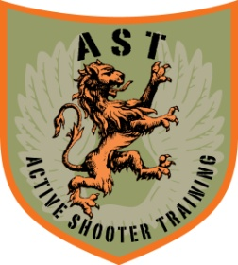 Chehalis Tribal Police Department is proud to host “Active Shooter Instructor Course” as presented by A.S.T. – Active Shooter Training LLC
WHERE: Oakville, WA
WHEN: July 24-28, 2023
TIMES: 0800-1600
COST: $750 per person
LODGING: Lucky Eagle Casino
REGISTER: nick@activeshootertraining.com
WHO: Course is open to law enforcement and military only
DETAILS: This is a 5 day, 48 hour course that is a combination of the Enhanced Active Shooter Course and the Active Shooter Team Leader Course. Upon completion, students will have the information and techniques necessary to plan and implement thorough, on-going training at their respective agencies. Course topics also include policy implementation and course development. The focus of this course is "what to teach" not "how to teach", students should be practicing instructors.
Students will need any/all deployment gear assigned to them or gear that they would actually deploy with. This course is a scenario based course and the will be conducted with the use of Simunition FX® equipment. Students will need their own conversion kit for rifle and or pistol plus approximately 125 rounds of Simunition FX®. Conversion kits and ammo are available at extra cost. Please indicate the need for rentals at the time of registration.
INSTRUCTOR: Lead instructor, Nick Minzghor, is a 28+ year Master Police Officer retired from the King County Sheriff’s Office and Marine veteran. Nick spent 6 years on the SWAT team as a sniper and was assigned to the Tactical Training Unit. Nick developed or co-developed every firearms program in use at his department today. He has been involved in the development and delivery of various active shooter programs since 2001. Nick is a competitive shooter, ranked as Master with USPSA and holds a Shodan ranking in Yang Ki Yin Jiujitsu.

