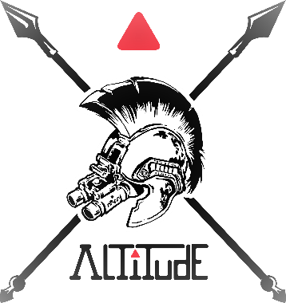
Spokane County Sheriff’s Training Center
13033 W. Medical Lake Road
Spokane, WA 99224
October 16-18, 2024

Basic Tactics, Techniques, and Procedures

Course Description:

This course is structured for Street Crimes Units, Undercover Units, or any other Investigative Unit that relies upon warrant service, vehicle takedown, or covert tactics, techniques, and procedures as part of their mission.

This 3-day Basic Tactics, Techniques and Procedures course has been developed from over 20 combined years of operational tactical experience in planning, training, managing, executing, and leading Drug Task Forces and SWAT Teams in high-risk and exigent circumstances incidents.

The training curriculum is reality-based and hands-on, designed to instruct, examine, and exercise the fundamental skills officers will require to enter a premises utilizing tactical methodologies. Students will learn and refine basic entry skills and techniques which will provide valuable and positive tactical experiences for timely, life-saving decisions during high-stress tactical incidents.

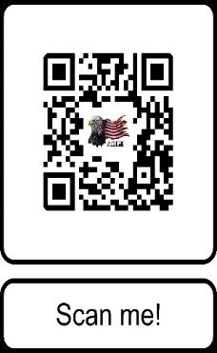
Course Duration and Fee:
3-Days:
8 am to 5 pm
24-hours of instruction
$405.00 per student

REGISTER ON-LINE At: Altitudetactical.com or Scan QR code.

Questions:
Please Contact Jack Rosenthal at 509.844.6065 or Jrosenthal@altitudetactical.com
For our additional courses and services provided, please visit Altitudetactical.com

Altitude Risk Mitigation, LLC
Do the right thing. At the right time. For the right reason!

