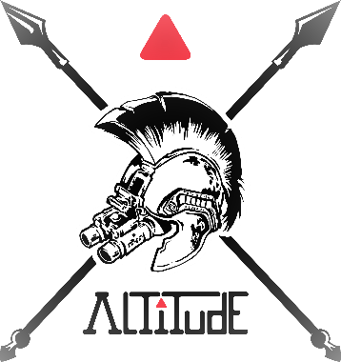
Spokane County Sheriff’s Training Center
13033 W. Medical Lake Road
Spokane, WA 99224
July 10-11, 2024

Leadership:
Command and Control for Critical Incident Response

Course Description:

This 2-day Leadership course is structured for Command Staff, First-Line Supervisors, and those who will become supervisors. The course is divided into two parts.
Day 1: The examination of tactics, techniques, and procedures required to effectively respond, control, and command the on-set of critical incidents; and Day 2: The handoff of that scene to the investigative branch and its continued management, command, and control of the scene until conclusion.

The course is Incident Command System, National Incident Management System eccentric, combining facilitated discussions and classroom exercises to solicit growth customized to the agency of the student. The purpose of the course is to guide leadership methodologies, techniques, and procedures in the response, command, and control in the initial response and continued management, of critical incidents law enforcement faces in their operational space.
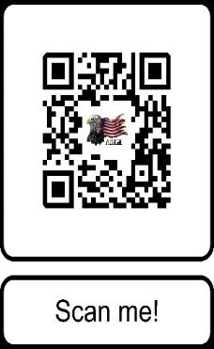
Course Duration and Fee:
2-Days:
8 am to 5 pm
16-hours of instruction
$295.00 per student

REGISTER ON-LINE At: Altitudetactical.com or Scan QR code.

Questions:
Please Contact Jack Rosenthal at 509.844.6065 or Jrosenthal@altitudetactical.com
For our additional courses and services provided, please visit Altitudetactical.com

Altitude Risk Mitigation, LLC
Do the right thing. At the right time. For the right reason!

