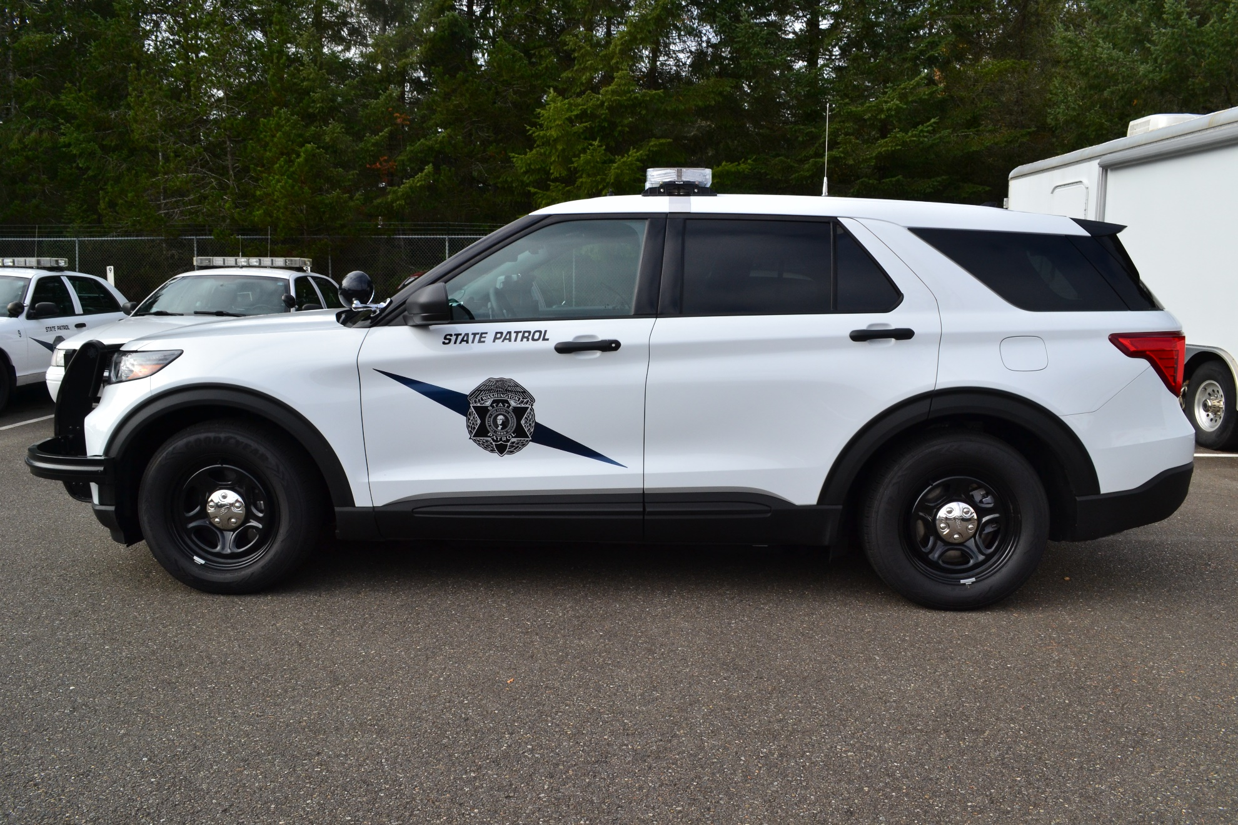

The Washington State Patrol will be sponsoring a Emergency Vehicle Operator Instructor Course in April 2023 for Commissioned Law Enforcement Officers. This course is five days in duration. The training is hosted at the Washington State Patrol Academy in Shelton, Washington.

The dates are: April 24th – 28th

This intense and challenging course is designed for officers assigned or will be assigned as Full or Part-Time EVOC Instructors. Students must have a CJTC Basic driving certification or Basic Law Enforcement driving certification from their state. The course covers Legal Issues, Vehicle Dynamics, Non-Emergency Driving, Emergency Driving, PIT (Pursuit Immobilization Technique), and more! Each student will also develop skills in advanced vehicle placement and skid avoidance/recovery exercises.

The registration fee is $1,576.28 and includes tuition, vehicle usage, and training materials. Full meals are $8.00, and the salad bar is $5.00. Meal tickets are available for purchase at the front desk. Due to the training environment and reduced room availability, lodging will not be offered.

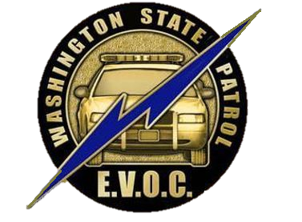
Contact: Washington State Patrol Academy
ATTN: Corporal Victor Duncan
631 W Dayton Airport Road
Shelton, WA. 98584-8945
(360) 432-7510- Office
(360) 507-6387- Cell
E-MAIL victor.duncan@wsp.wa.gov

