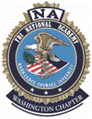

**Register now!**

**FBINAA Washington State Chapter Presents:**

**Internationally Renowned Speaker and National Academy Graduate Paul Butler Speaking on “Leadership for Life”**

**Who**: **Bring the Team!** Today’s Law Enforcement Needs to Hear Paul’s Message!  
**When:** Wednesday, December 6, 2023; Arrive 8a, Training at 9a, Lunch at 12:30p (included)  
**Where:** Alderwood Community Church-3403 Alderwood Mall Blvd, Lynnwood WA 98036

**Cost:** $80 FBINAA Member  
 $40 Retired Member  
 $100 Non-Member

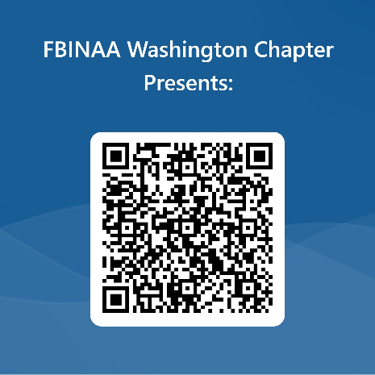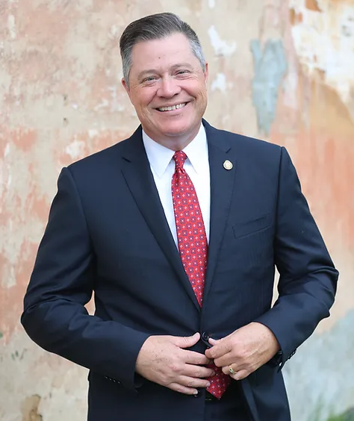



GOOD QR CODE

**Host Hotel:** Hilton Garden Inn (4 blocks from training venue)

Dec. 5th 3801 Alderwood Mall Blvd, Lynnwood WA 98036 (425) 320-5905

Ask for FBINAA Per Diem Rate – limited rooms/don’t delay!

**Sponsor:**