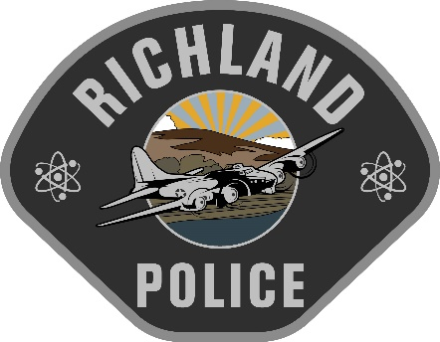

Presented by Glock, Professional, Inc.

Hosted by the Richland Police Training Center
3230 Twin Bridges Road Richland, WA 99354
Tuition: $250.00 (Lunch Included)
Oct 10, 2023: 0800-1700

Registration Link: https://glocktraining.com/RegWizard.aspx?classid=110366
Host Agency Contact: Jory Parish 509-942-7338 jparish@ci.richland.wa.us

Special Lodging Rates:
Just Mention RPD Training at booking for discounted rates.

Hampton Inn Richland

Homewood Suites Richland

Holiday Inn Richland on the River

