wsp crime lab 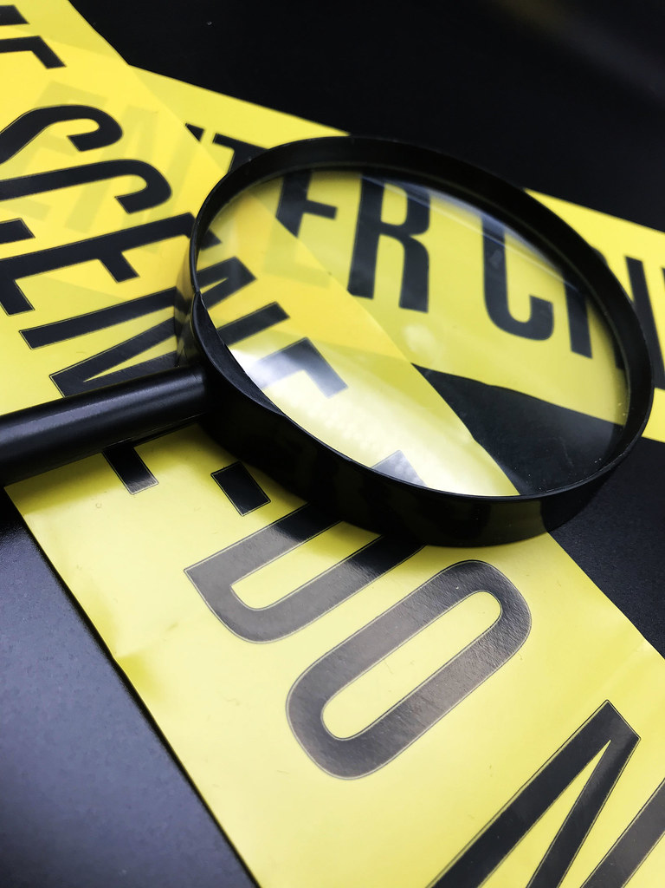training  This Photo by Unknown Author is licensed under CC BY  April 4th, 2024 Thursday  8am – 5pm  Location:  Moses Lake Police Department- Training Theater  401 S. Balsam Street  FEATURING · Forensic experts in DNA analysis and Firearms. | FREE CLASS  Forensic Services Overview  Types of analysis  Evidence Collection and Submission  How to submit  Class Description-  WSP Crime lab forensic experts will share valuable information about forensic evidence collection and the types of analysis they conduct. This class is designed for detectives, patrol officers and property and evidence specialists.  To register:  Contact- Jeff Sursely  509-764-3887 jsursely@cityofml.com

