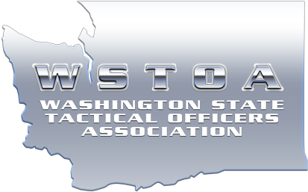

WSTOA SWAT BASIC – Spokane, WA
May 6th – 10th, 2024

Event Details:
WSTOA’s Basic SWAT course is 5 days and 50 training hours. The focus of WSTOA’s Basic SWAT course is to provide students with the basic required knowledge for officers and deputies newly assigned to SWAT or Tactical Response Teams. The target audience are individuals who have recently been assigned to SWAT. They will gain an understanding of contemporary theories and concepts used during SWAT operations. Students will participate in classroom and field exercises designed to develop their understanding of the tactics and techniques employed during tactical operations. This course is facilitated by experienced SWAT team leaders and elements leaders currently assigned to Tier 1 and Tier 2 SWAT teams who are experienced in developing newly assigned SWAT officers.

The primary course objectives are as follows:
- SWAT Theory & Concepts in order to gain an understanding of SWAT utilization during tactical operations.
- Team organization and structure, to include the responsibilities of each position within the team.
- Introduction to specialized equipment and munitions used by SWAT Teams.
- Tactics used during armed barricaded incidents and high-risk warrant service missions.
- Proper Scouting and Operational Plan & the necessity of after-action reviews.
- Dynamic, Slow and Methodical, and Covert movement techniques.

Required Equipment:
Helmet
Entry Vest
Gloves
Tactical Uniform
Rifle/SMG
Handgun
Eye and hearing protection
APR (Gas Mask)
PT gear
Simunition, Force on Force, UTM bolt or rifle with 150 rounds of marking cartridges
Simunition, Force on Force, UTM protective gear

Location:
Spokane Police Academy
2302 N Waterworks St, Spokane, WA 99212

Time:
Course begins at 0800 on Monday May 6th, for student check-in and NTOA PFQ. Attire is PT Gear.

Cost:
$500.00

Click here to register:
https://www.wstoa.org/swat-basic-registration/

Cancellation:
Deadline to cancel is 7 days prior to class.
$500 no show or late cancellation fee.

Questions?
Contact Matt Nelson at mnelson@ci.richland.wa.us

