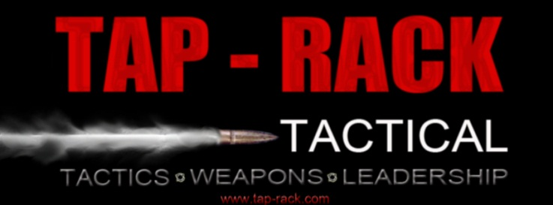
PO Box 971, Puyallup, Wa. 98371
Phone: 253-318-4972
Email – bill@tap-rack.com
www.tap-rack.com

Basic SWAT

This class will focus on the basic understanding of SWAT operations including: SWAT history, liability issues, physical fitness/wellness, SWAT equipment/weapons individual and team movement, intelligence gathering, mission planning, barricaded persons, high risk warrants, less lethal/chemical/NFDD issues and a large focus on team building. At the completion of training, students will be able to function as part of an entry or containment team. Students are required to bring all of their tactical gear for hands-on training evolutions. This is not a course in the classroom; you will plan and execute numerous missions during the five-day course at different sites.

Length: 5 days
Tuition: $800

Hosting agency: Okanogan County Sheriff’s Office
Hosting POC: Stefan Wolak swolak@co.okanogan.wa.us
Recommended lodging: Best Western Plus Peppertree Inn at Omak; 12 Tribes Omak Casino Hotel

Course Overview:

This course is designed to teach officers the basic skills required to safely and effectively operate as SWAT team members. Officers learn through the use of classroom instruction, video, demonstration and extensive field exercises. Topics include team structure, tactical movement, scouting, raid planning, breaching, weapon handling, entry, vehicle assaults, officer/victim rescue among other specialized skills and tactics.

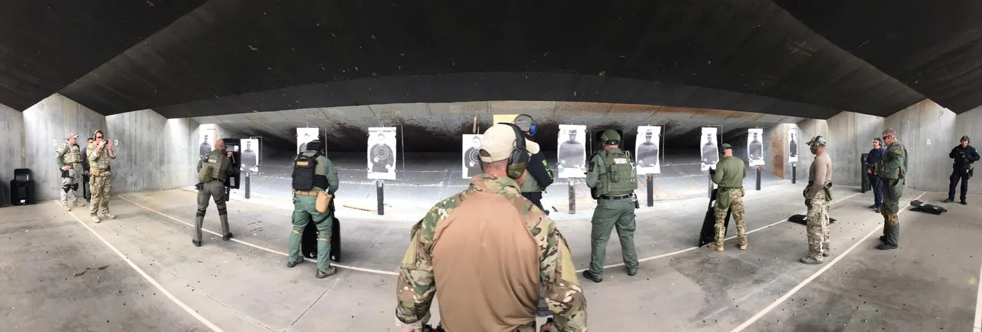

Equipment List:

Bring all personal gear issued by your team, this includes:

Duty uniform(s)
Seasonal Boots
Heavy Ballistic Vest
Load bearing equipment/vest
Duty belt and Holster
Cold/Wet weather gear
Issued Long gun and handgun
Helmet
Eye & ear protection
Gloves (Something you could shoot with)
Gas Mask
Note taking material
1 doorstop & 25 feet of 550 cord, flat rope, or similar.
Anything else you need to maintain comfort level for the season.

YOU WILL BE OUTDOORS!

Not required, but nice to have
CamelBak or canteen
Digital Camera / Cell Phone
Bino’s
Laptop w/wireless internet

