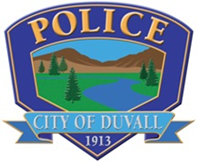
Duvall Civil Service Commission
*** Immediate Opening for Patrol Sergeant ***
$8,115.25 - $8,957.67/month based on 2190-hour annual work cycle

Application Period: December 13, 2021- February 1, 2022
In order to qualify for City positions, a City application must be completed and received by the stated deadline. Application and position description are available on-line at:
https://www.governmentjobs.com/careers/duvallwa
Please review automatic and potential disqualifiers; please upload a copy of your Peace Officer Certificate along with your application in NEOGOV.
Receipt of Applications: Applications must be completed in NEOGOV and paper applications will not be accepted.
Officer benefits:
12 hour shifts 4 days on/4 days off, Degree incentive: $100 per month for AA degree & $225 per month for BA/BS, 10 paid holidays per year, 2 paid personal days per year, Vacation accrual from 96 hours - 200 hours per year, 96 hours sick leave per year, Health insurance (employee pays $100 per month for family), Longevity ranges from 1% - 4%, Workout time on duty, All duty equipment/firearms provided- jumpsuits/tac-vest issued, and much more!

